**Task-4**

**Windows Server with MSSQL Express**

**Details-** Download MSSQL Express and SSMS, Enable SQL Authentication, set sa user with password, change data,log,backup to D Drive, Create another user with System Admin permission, change port from 1433 to 1444, login to that mssql server from local system through ssms, create a database, take backup of that database.

**1.Launch an instance for Window Server.**

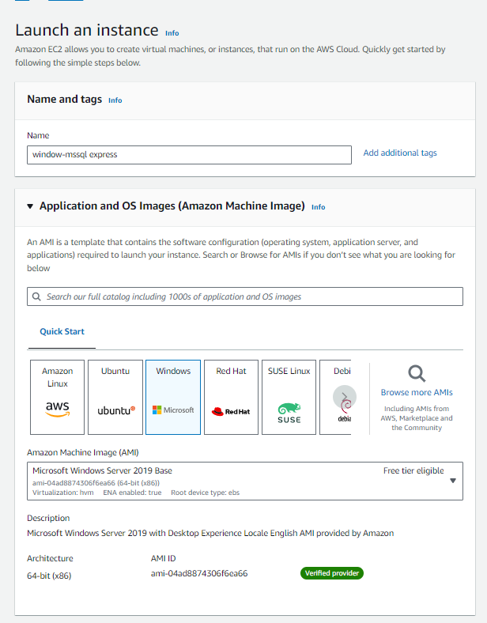 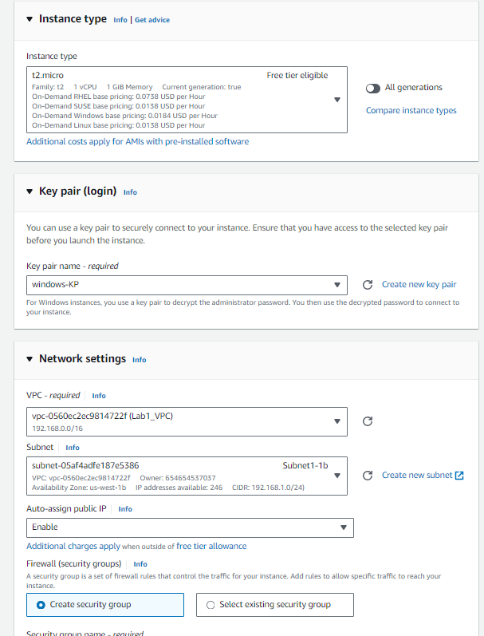

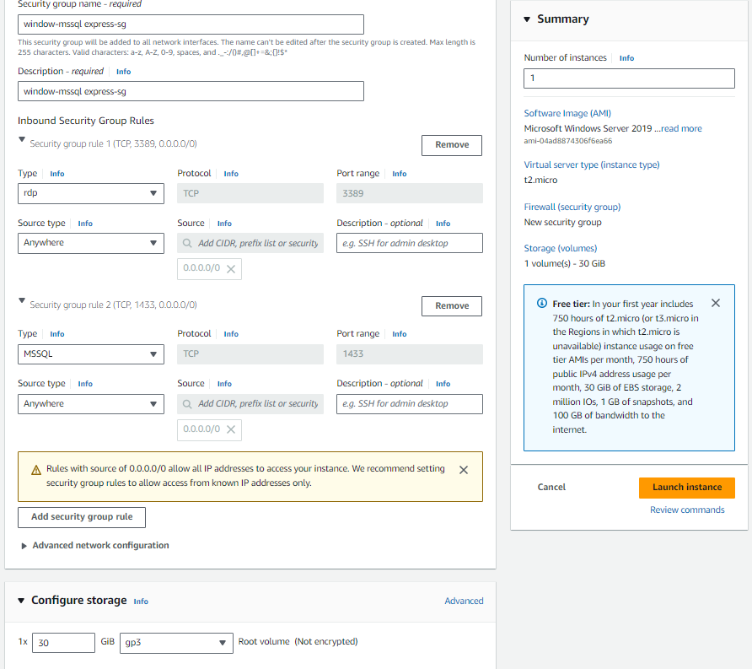

**2.Connecting with Remote Desktop Connection.**

2.1 Give the public IP of instance in computer and name it as Administrator and connect it and click on get password and decrypt the password by giving .pem file of instance.

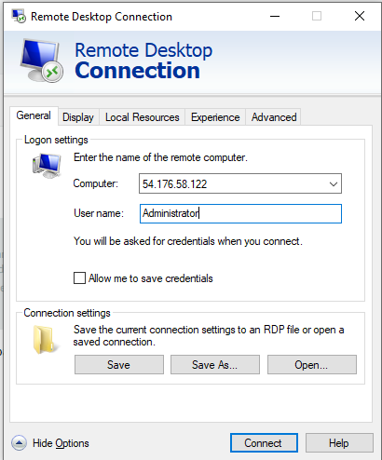 

3.Download Windows MSSQL Server Express

Search MSSQL Server for Windows-> Click Download Now-> Click on Run-> Choose Basic->Accept License->Click On Install->

After setup complete click on close.

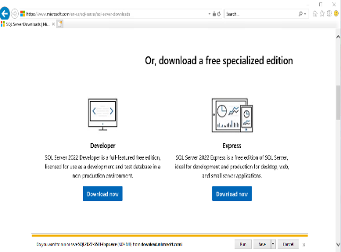 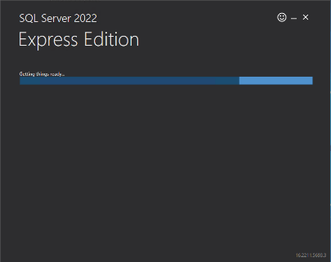 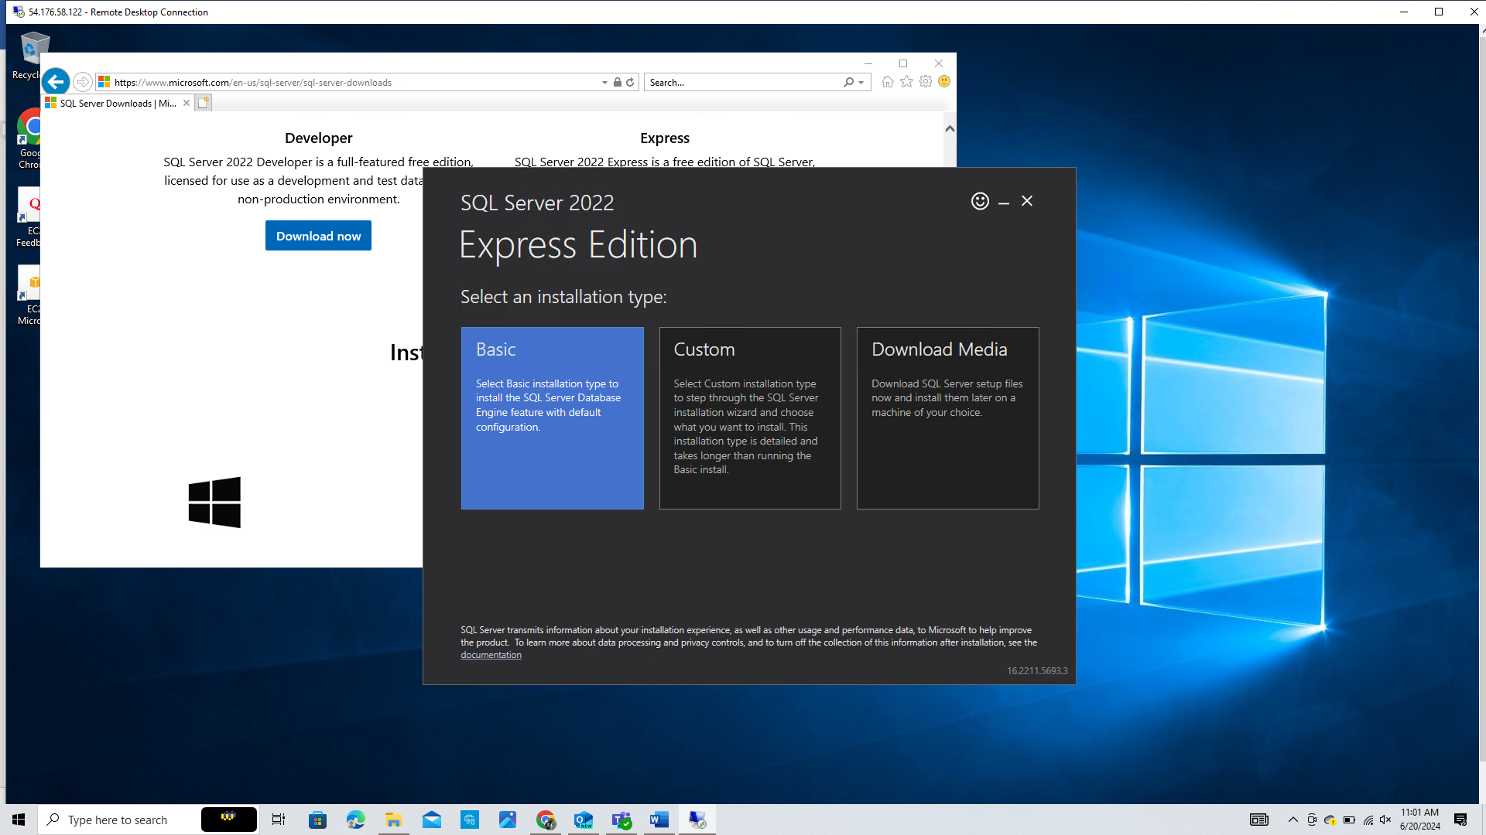 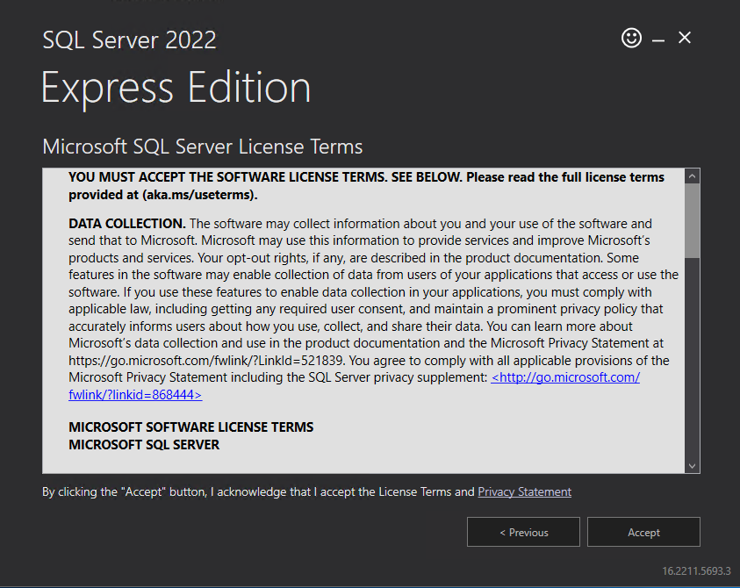

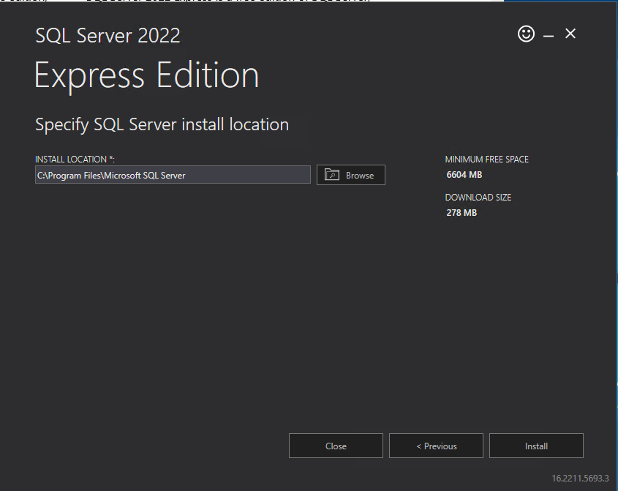 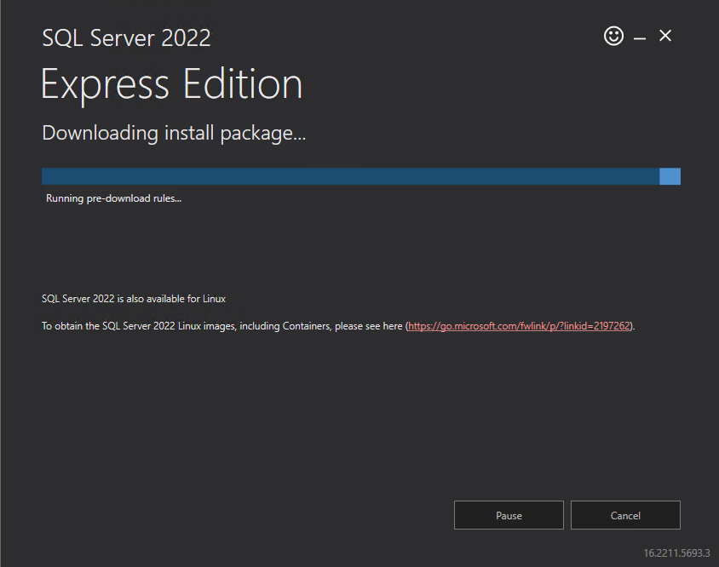 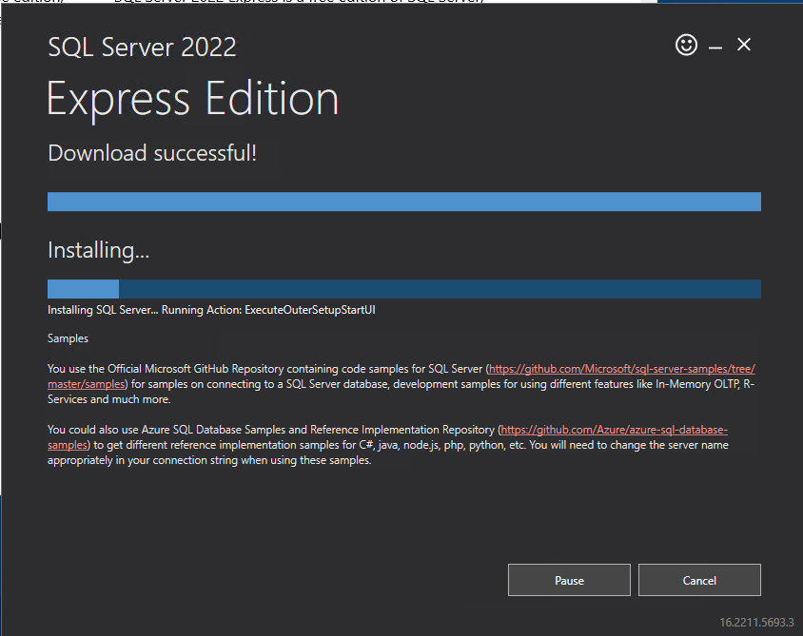 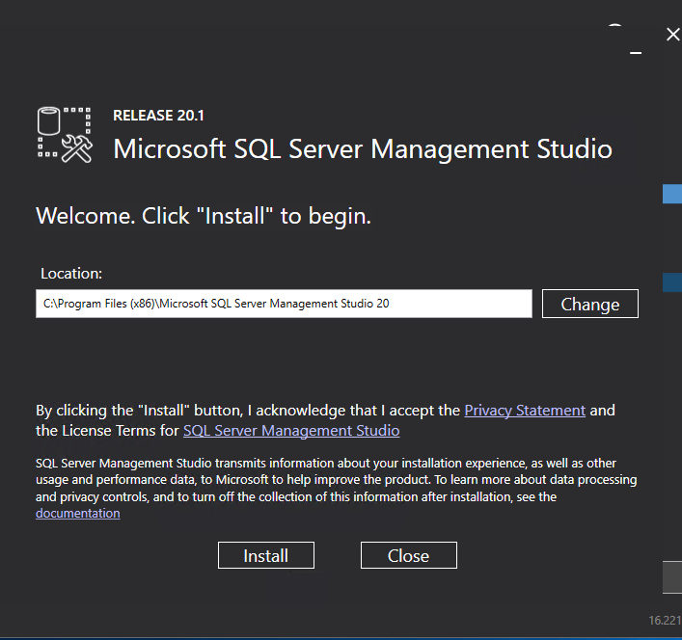

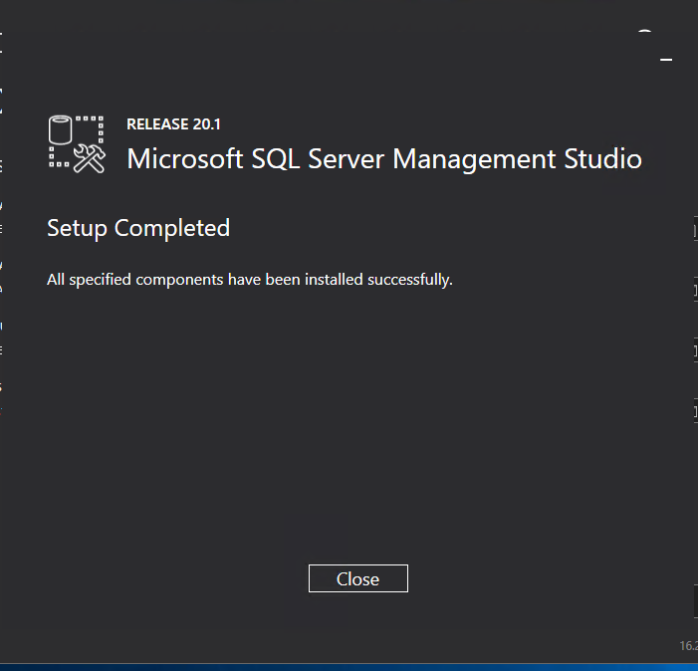

**3.1 Installing SSMS**

Click Install SSMS->Click Download SQL Server Management Studio-> Run->Restart SSMS

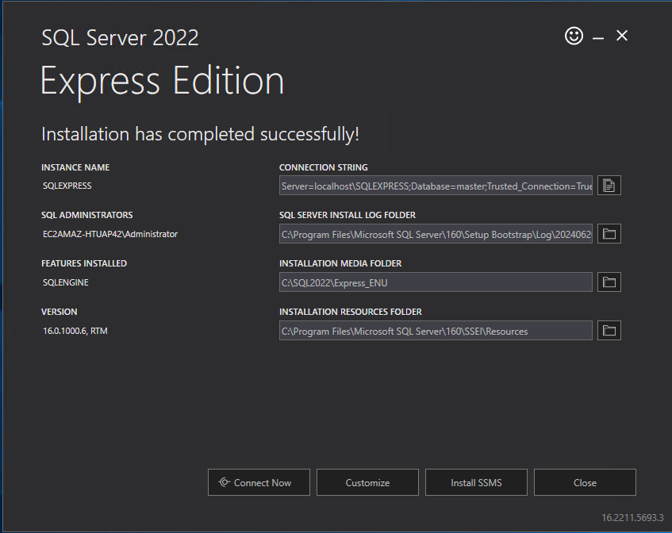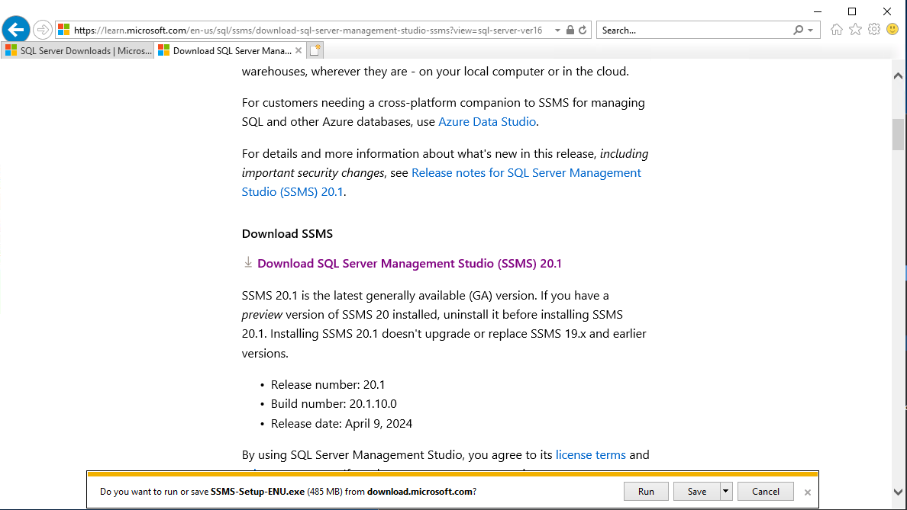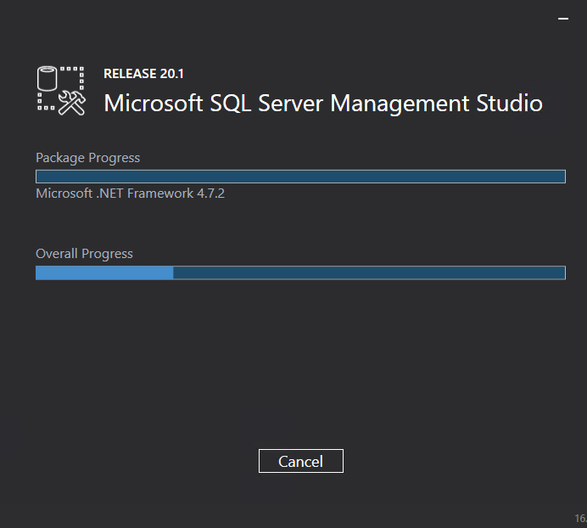

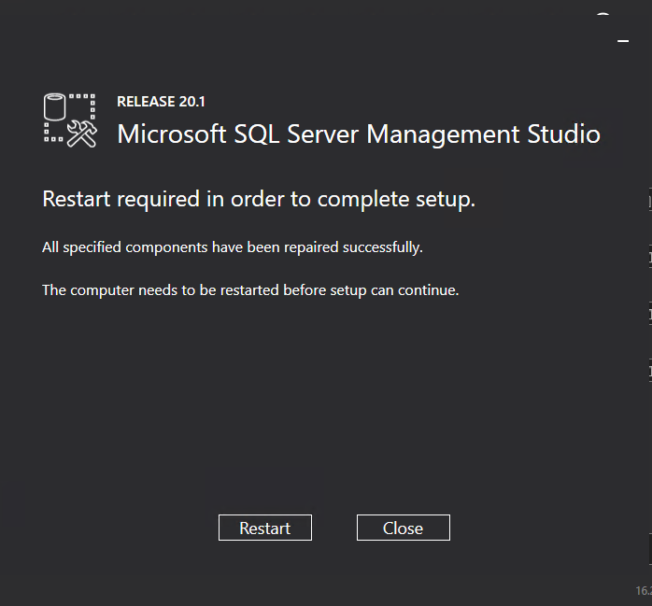

**4.Go to SSMS and Login SSMS**

**SSMS-SQL SERVER MANAGEMENT STUDIO**

* Connect to SSMS

Server Name: EC2AMAZ-HTUAP42\SQLEXPRESS

Click on Connect

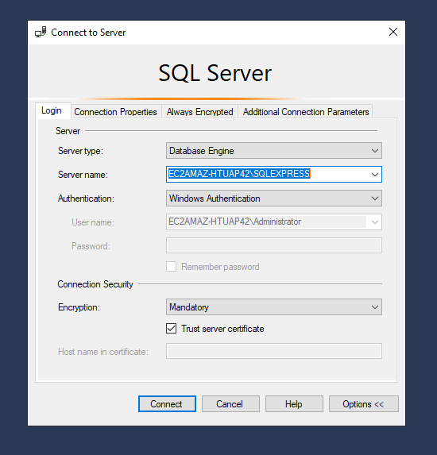 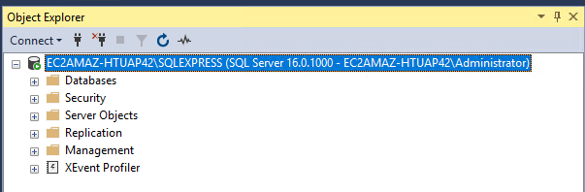

**Right Click on Server name(Named: EC2AMAZ-HTUAP42\SQLEXPRESS)->**Go to Properties->Go to Security Section->In server Authentication->Select SQL Server and Windows Authentication Mode->OK->Microsoft SQL Server Management Studio will restart->OK.

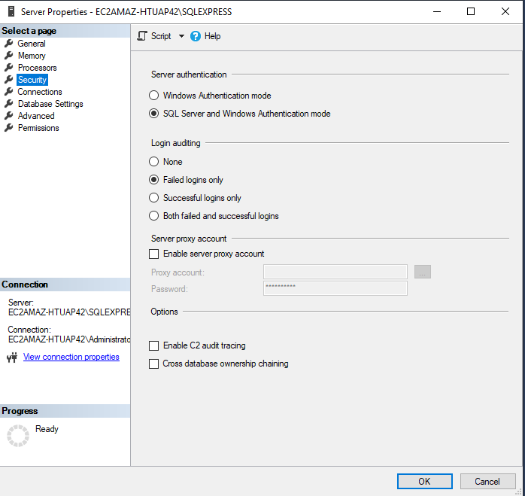 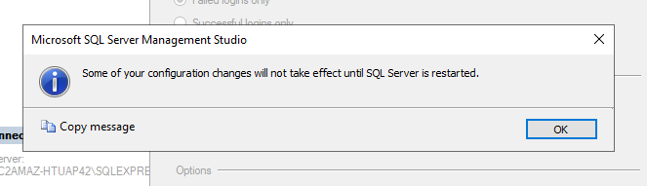

**5.Go to Security->**Logins->Go to user sa->Change the password->then go to status->Login->Choose Enable->Press the Refresh icon->Right Click on server name->Restart the server->Connect with sa user in SQL Express.

**Then User->sa Password->Admin_1234**

**Then do ok and logout from authentication**

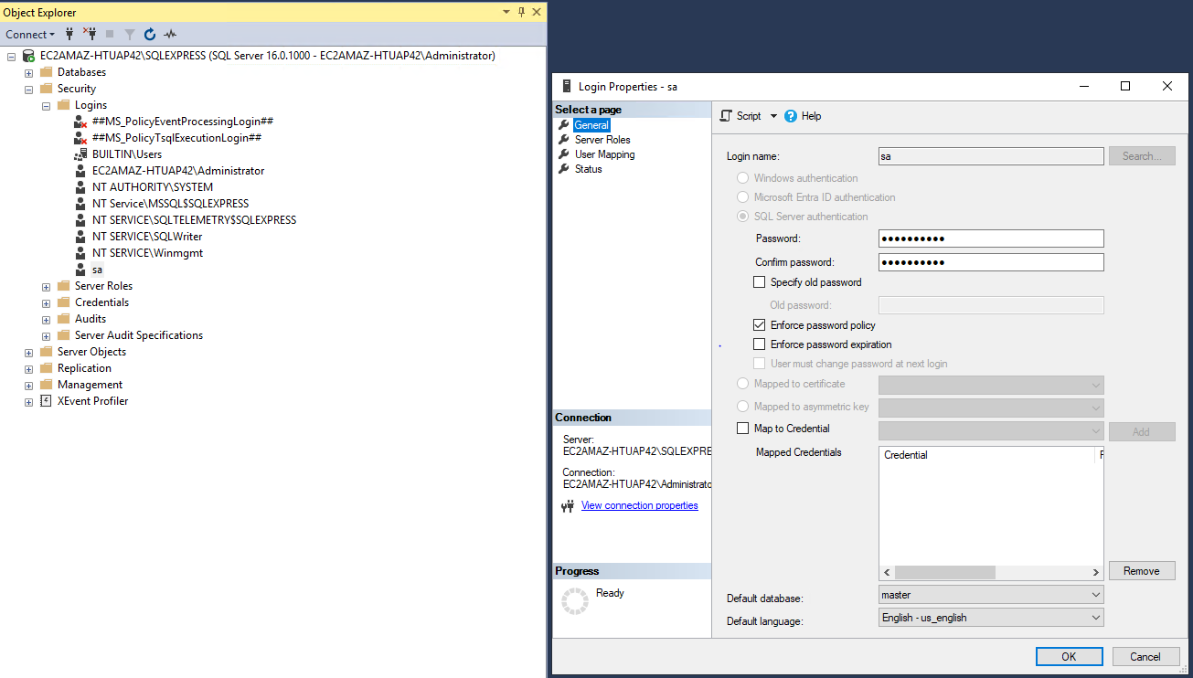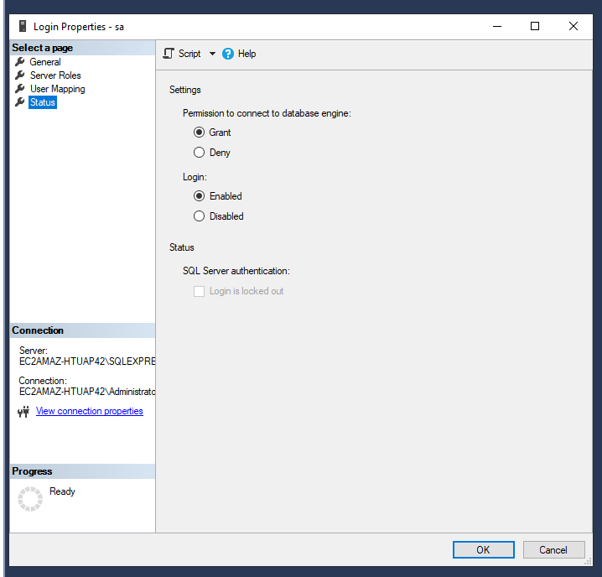

**5. Restart the MSSQL Express services of SQL.**



**6. Login again with SQL Server of MSSQL->change authentication to SQL Server Authentication->Give Login:sa->Password-admin_1234->In Connection Security->Select Trust Server Certificate.**

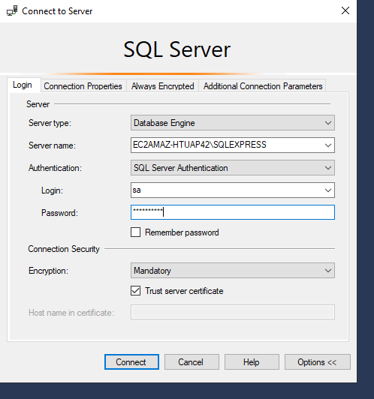 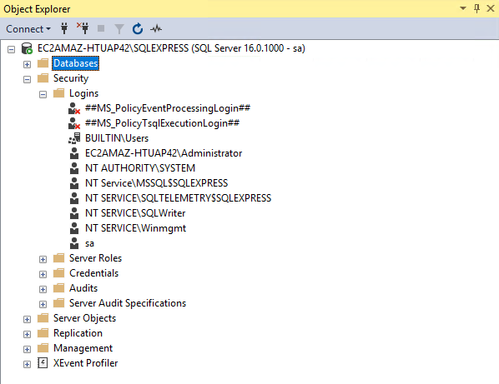

**7. Attaching Volume with instance**

Create volume-> make size 10 GB->Attach volume with instance->In Attach Volume->Choose your Instance of MSSQL->Give: Device name: xvdc ->Click Attach volume

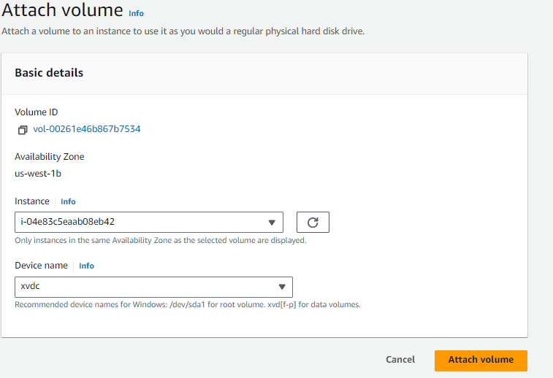

**8. Volume Attached**





**9.Creating D Drive**

* Before Adding Disk

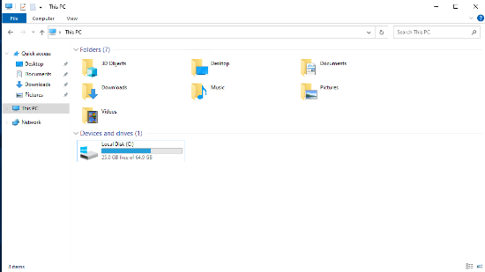

**Steps for adding D drive:**

**Search Computer Management->**Go To Disk Management->Right click on unallocated partition->Choose Simple Volume->Choose next->Specify volume size->Assign the drive letter(D:)->In format partition choose next->Click Finish.

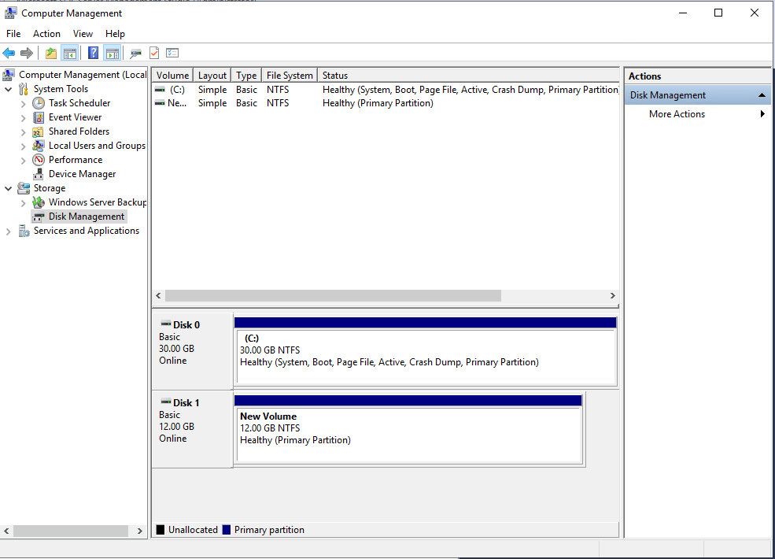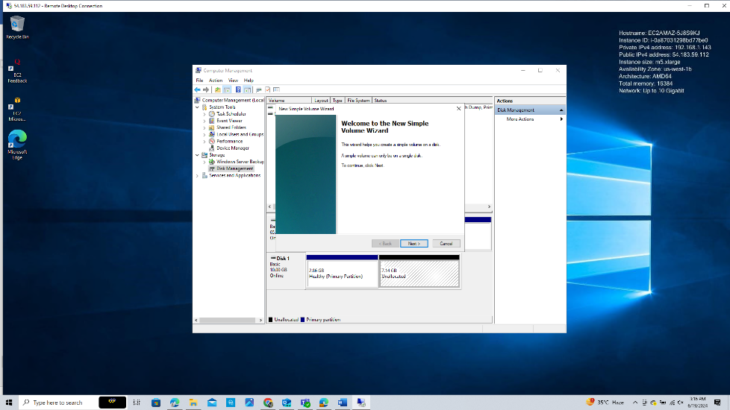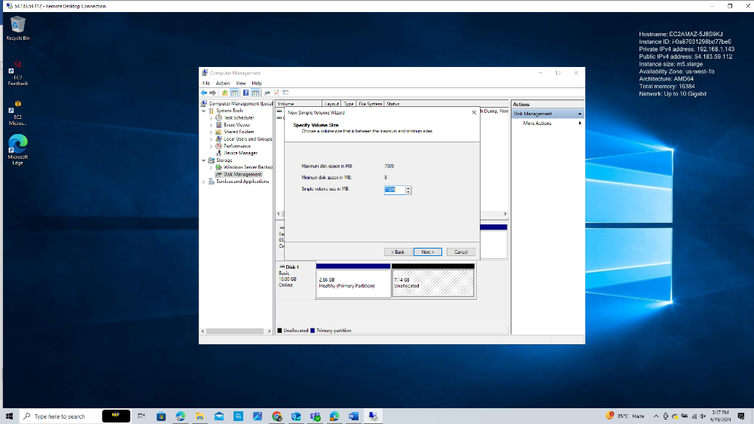

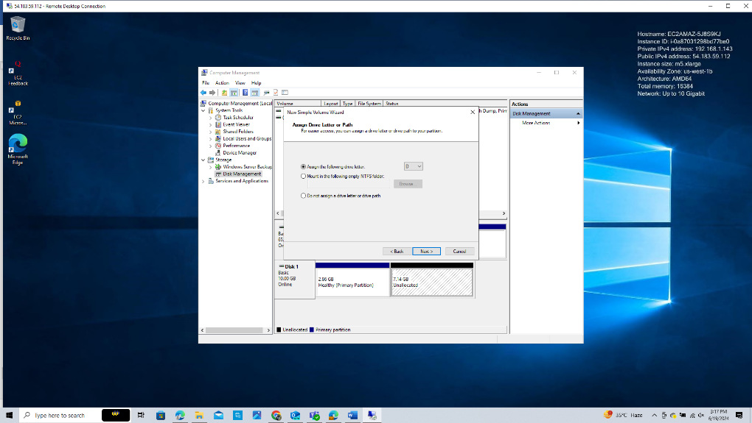 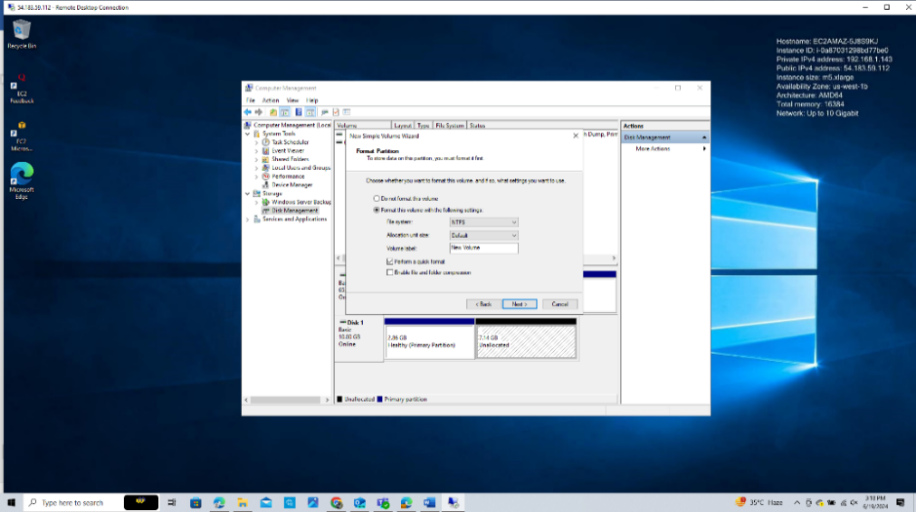 

**10. Creating the database for log, data and backup purpose.**

Right click on Databases->select new databases->Give name: workmate->select workmate->Right click on it->Select new query.

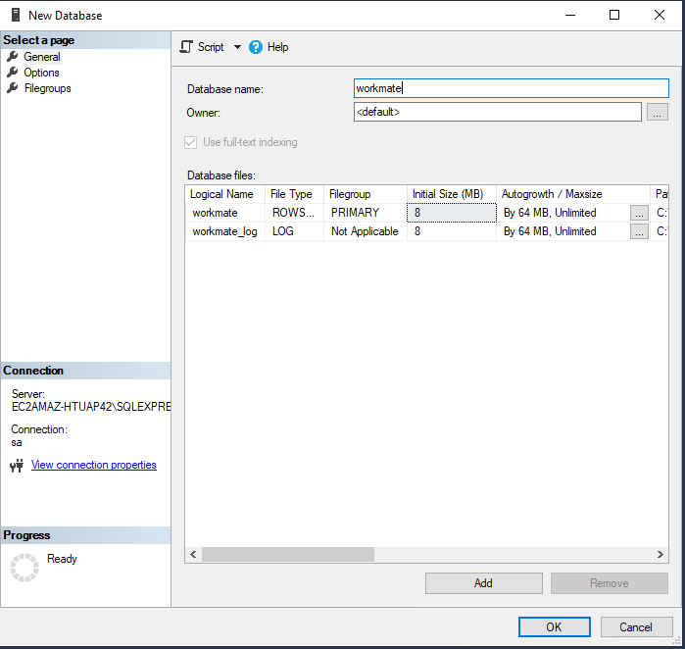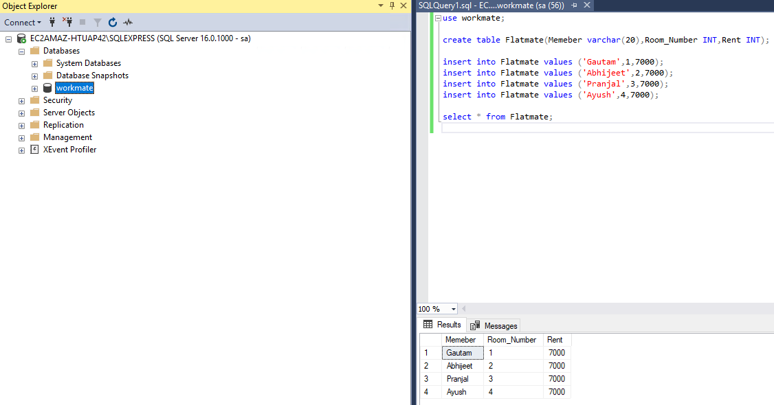

**11.Taking Backup in D drive.**

Select Database: Gautam->Right click on database->Go To Task->Go to Backup->Add folder path to keep data backup D: drive.

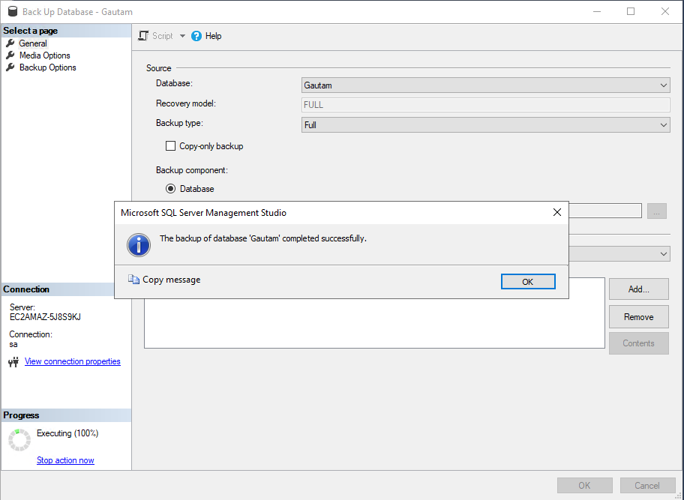 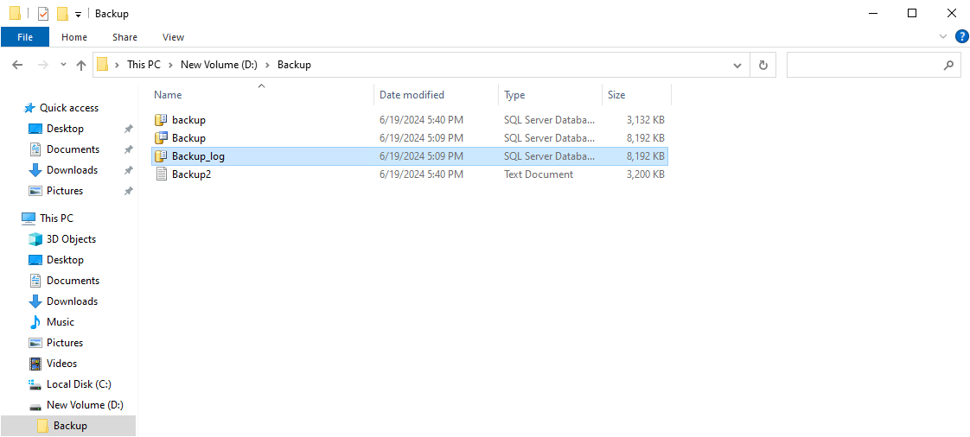

**12.Create another user with system admin permission**

**Steps:**

Go to Security->Logins->Right Click on it->General: Give name->Choose SQL Server Authentication->Give Password->Give Permission to: sysadmin->User Mapping :Choose all map->Keep status: Enabled->Disconnect with sa user->Connect with Gautam User by giving name:Gautam and password:admin_1234->It will ask give new password->Give new password->Click OK

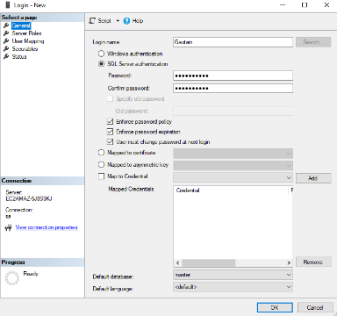 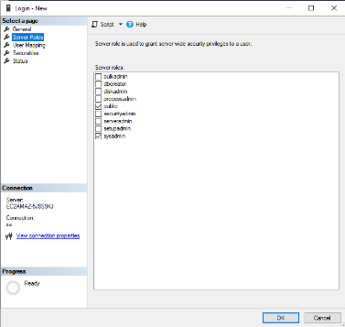 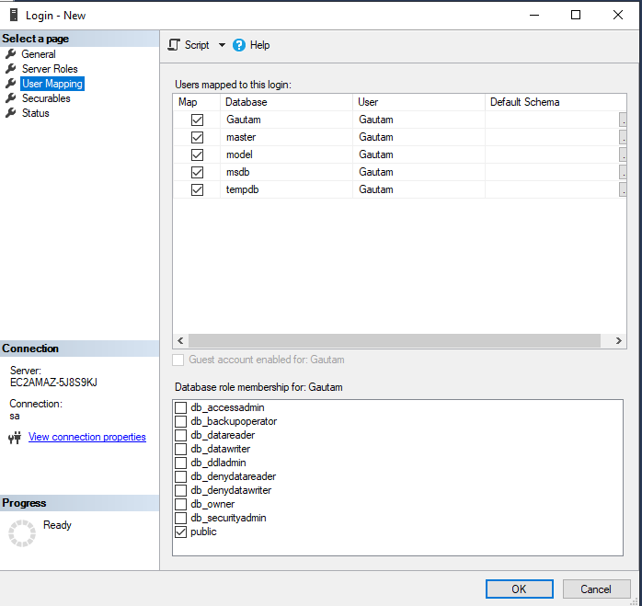 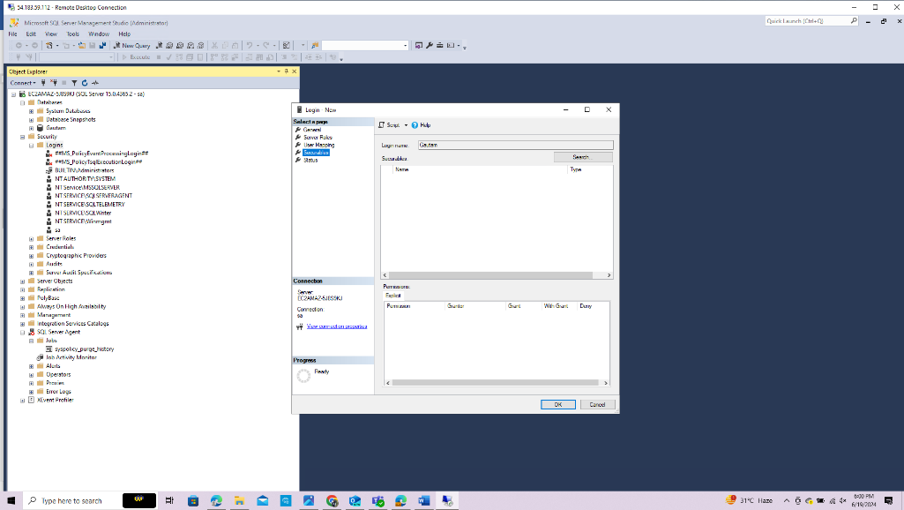

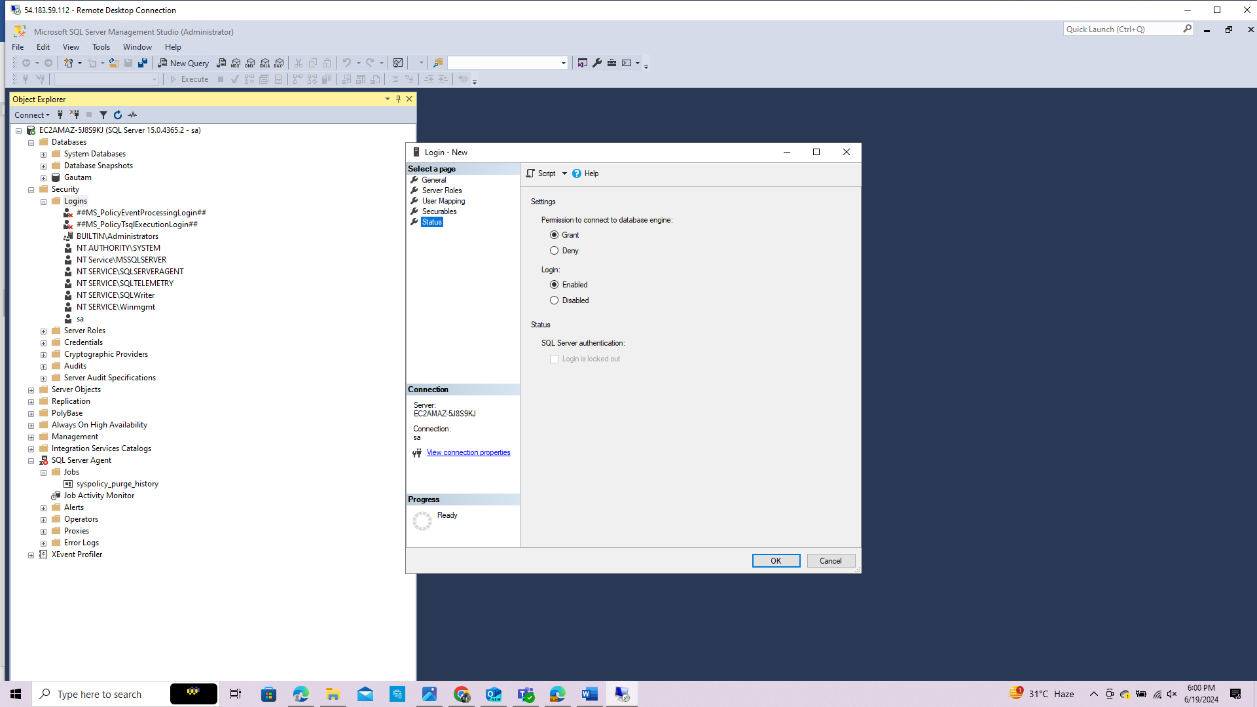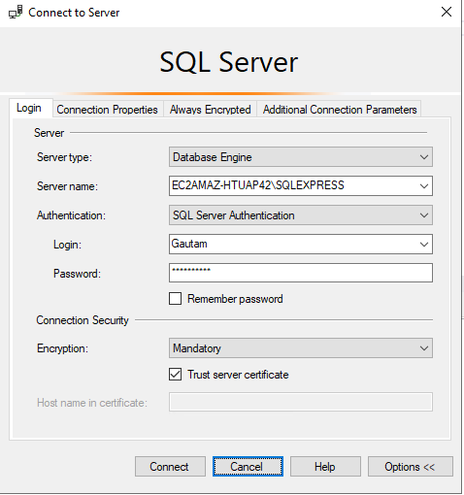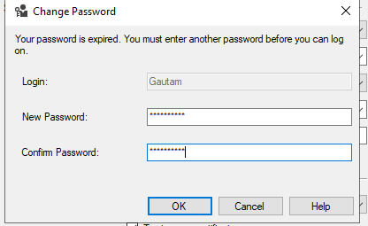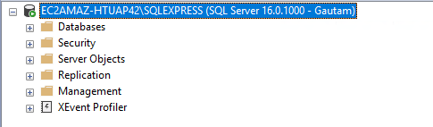

**13. Changing the port number from 1433 to 1444, security group and added new inbound rule in the windows firewall.**

Open SQL Server Configuration Manager -> Expand SQL Server Network Configuration and click on Protocols for MSSQLSERVER->Right click enabled the TCP/IP->Right-click on TCP/IP and select Properties->Go to the "IP Addresses" tab->Scroll down to the IP All section and change the TCP Port from 1433 to 1444.->Click OK ->Restart the SQL Server service for the changes to take effect.

And also change the port in the firewall ,security group adding custom (TCP) and restart the SQL Server.

**13.1 Adding new inbound rule in window firewall.**



**13.2 Editting the Inbound Rule Of Instance.**

**Click SG Of Instance->**Click Add Rule->Choose custome(TCP):1444->Click on Save Changes

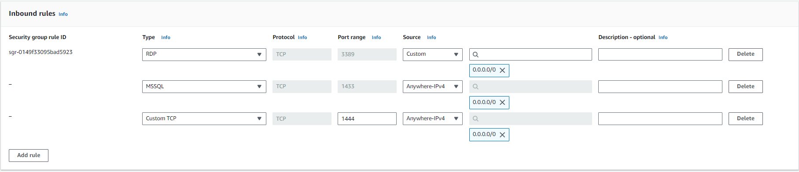

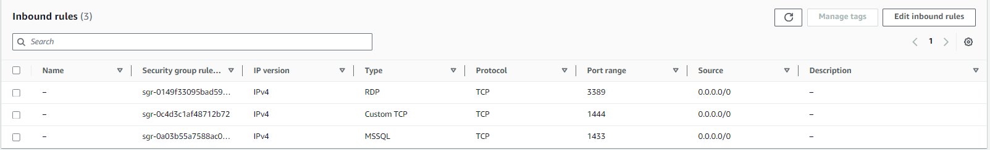

**13.3 Changing the Port in SQL Server Configuration Manager,SQL Native Client 11.0 Configuration,SQL Server Network Configuration.**

13.3.1 SQL Server Network Configuration->Protocol for MSSQL Express->Right click-on TCP/IP->Enabled the TCP/IP->IP Address->Change the port from 1433 to 1444

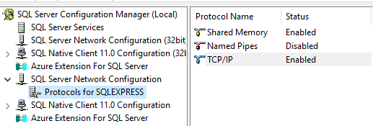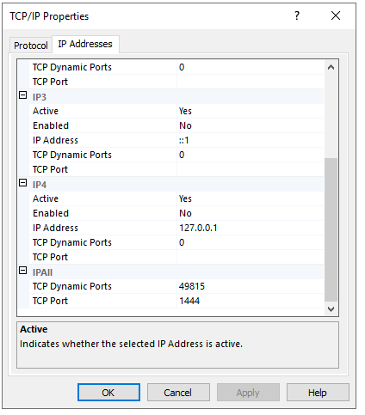

**13.5 Loging in with MSSQL Server after changing the port Of MSSQL Server.**

**Loging MSSQL Server after changing port MSSQL Server Logged in**

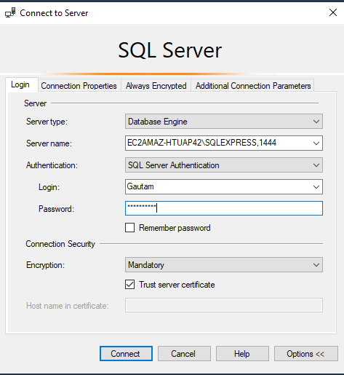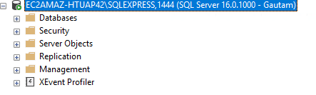

**14.** **Login to that mssql server from local system through ssms, create a database, take backup of that database.**

**14.1 Created the database.**

Create Databases-Right Click on Databases->Choose New Databases->Right click on created database->Give name of Database->Click OK->Expand te database section

->Choose your Database:Gautam->Right click on Gautam->Choose New Query-> Write Query for insertion of data into the databases.

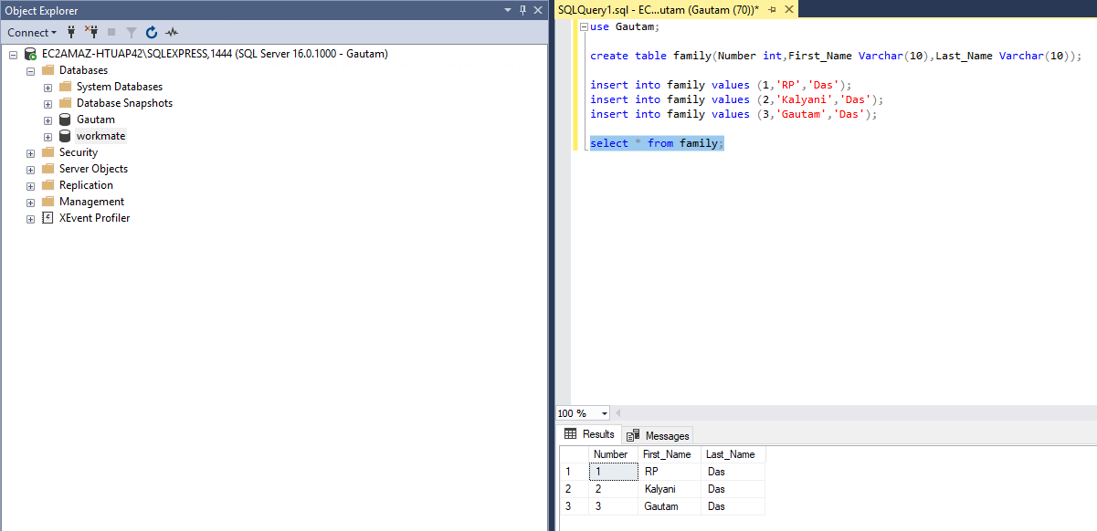

**14.2 Taking the data backup**

Steps of taking the backup of whole data.

Right click on Database name Workmates-->Task->Backup Data->Click Add->Add Backup data into folder->Ok

* If you want to take backup of whole data follow the above steps and for whole data backup the extension

Format will be in .bak format.

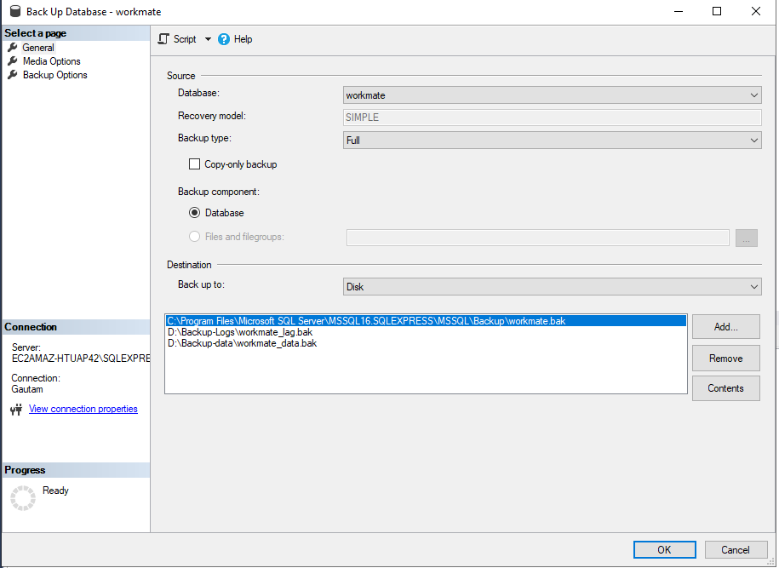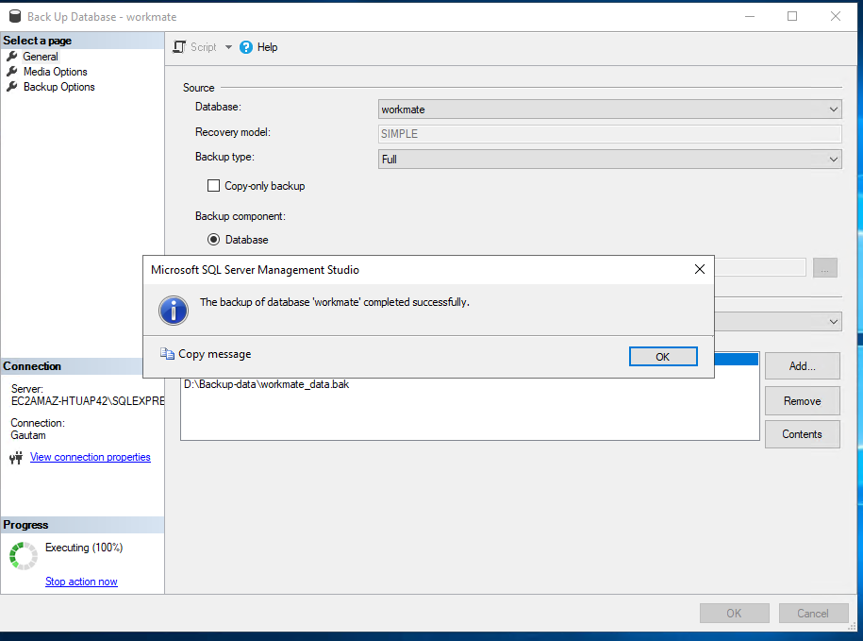

**14.3 Showing the folder of backup data.**

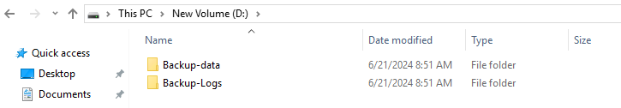

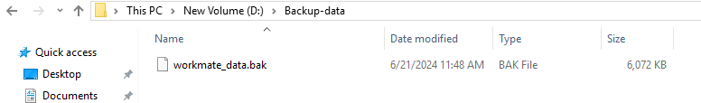

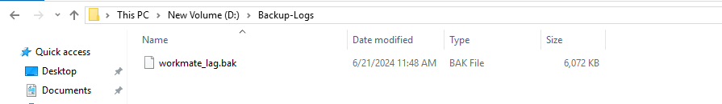

**CREATE RDS WITH MSSQL**

**1.Creating Databases for MSSQL Express**

**Select Database->**Choose database: Standard Create->Engine Option: MSSQL Server->Edition: MSSQL Server

Express Edition->Engine Version: SQL Server 2022 16.00.411.5v1->Template: Free Tier

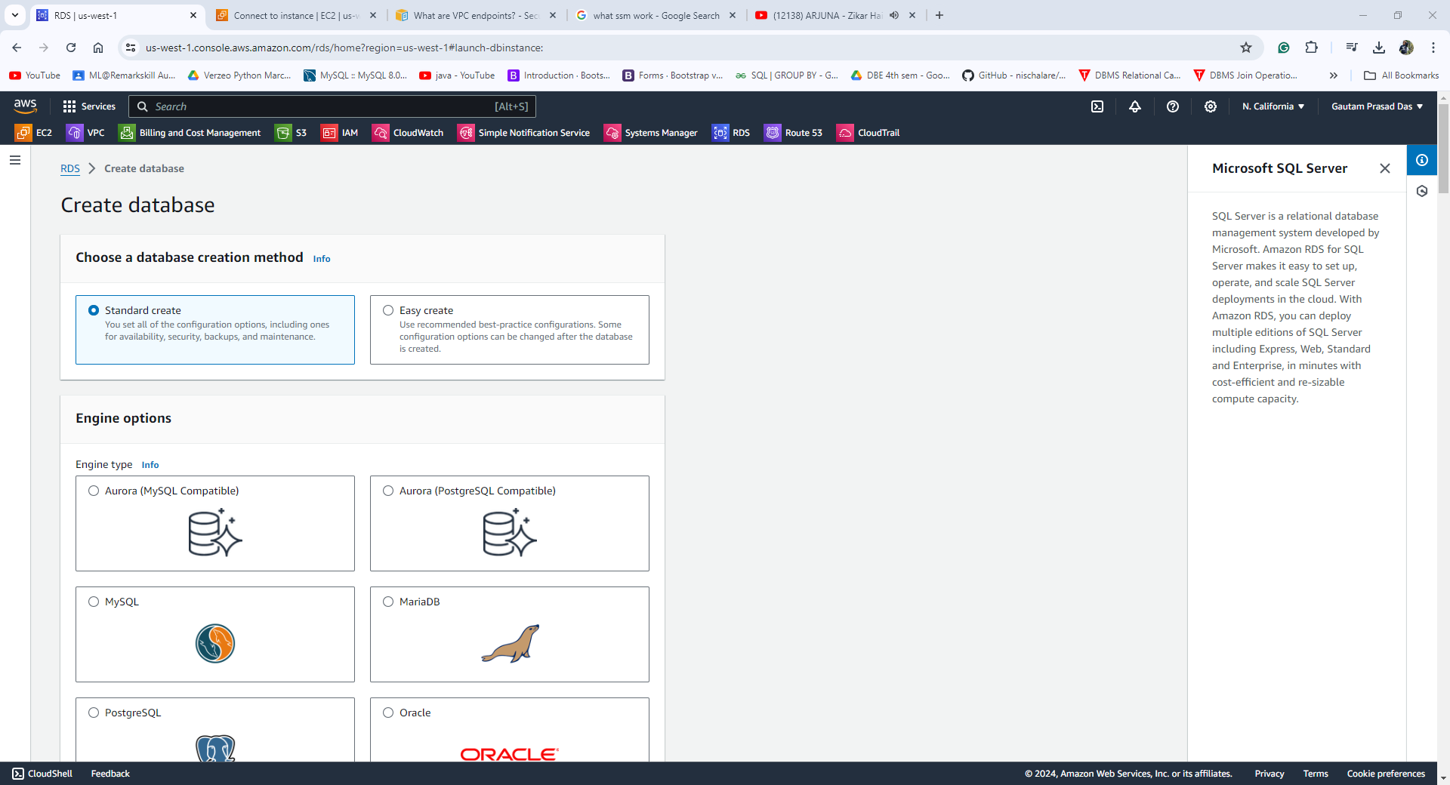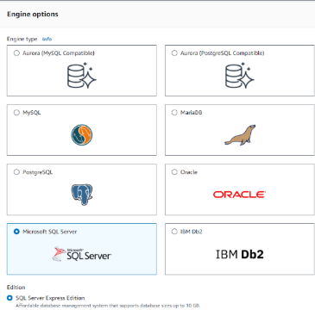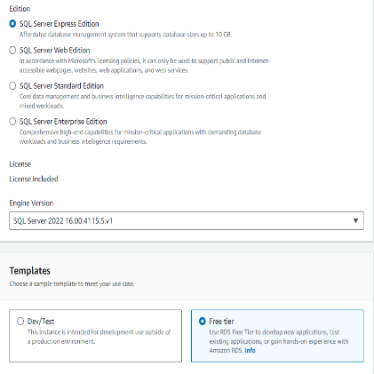

**Go To Settings->** DB instance identifier-mssql_express_db->Credential Setting->Master Username: admin ->

Credential Management: Choose Self Managed-> Master Password: admin_1234

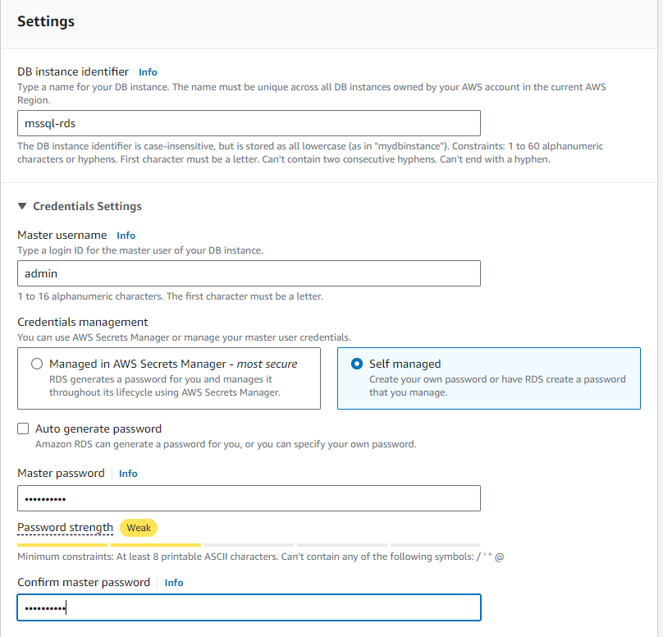

**Instance Configuration->**DB Instance Class->Choose Burstable Classes and db.t3.micro.

**Storage->**Storage Type: General Purpose SSD(gp3)->Allocated Storage:20

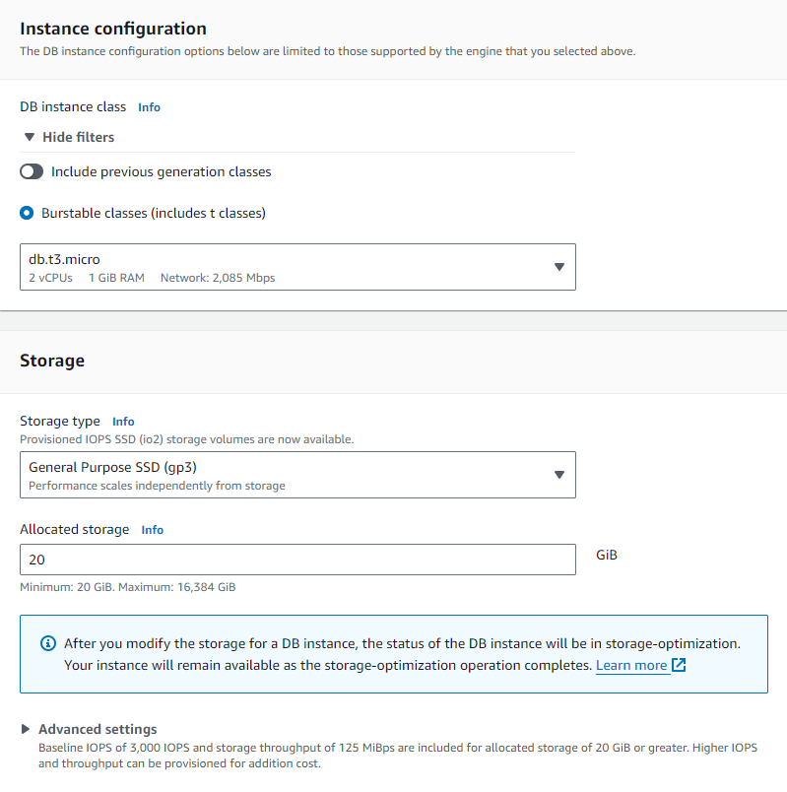

**Connectivity**->Compute Resource->Choose Don’t Connect to an EC2 compute Resource->Network Type: Choose IPv4->VPC->Choose your VPC->DB Subnet Group: Choose Private Subnet: rds public subnet->Public access->No->VPC security Group->Choose Create new->New VPC Security Group Name: RDS-MYSQL-SG->Availability Zone:us-west-1b->Certificate Authority->Keep it default

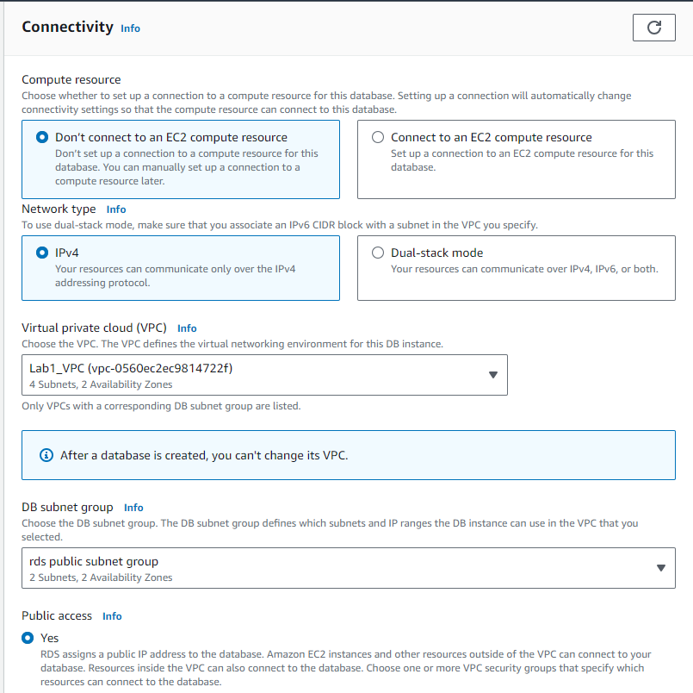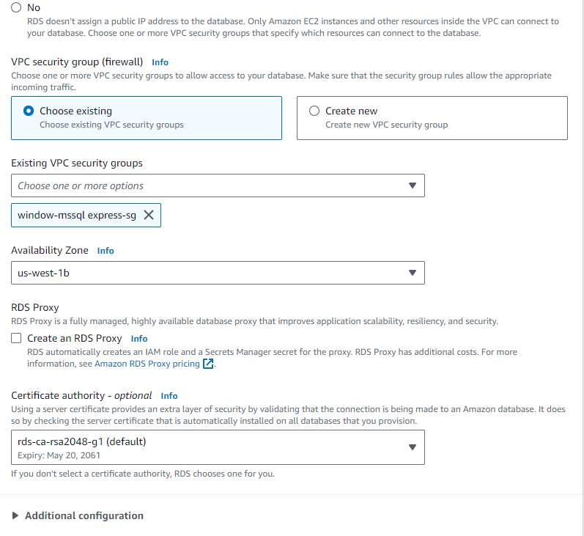

**Database Created**

